CONFIDENTIAL  CS/NOV 2026/ICT450

UNIVERSITI TEKNOLOGI MARA
MARKING SCHEME

COURSE :
COURSE CODE :
EXAMINATION :
TIME :
DATABASE DESIGN AND DEVELOPMENT
ICT450
NOVEMBER 2026 (MOCK)
3 HOURS

MARKING SCHEME NOTES

- This marking scheme accompanies the ICT450 mock paper (November 2026).
Answers are unofficial model answers, not official UTM marking schemes.

- Marking points state the expected answer and the allocation of marks; every question retains its source paper and page reference.

- Five questions x 20 marks; total = 100 marks.
- Real-bank questions: 5. Placeholders: 0.
Questions and answers are for local study use only.

- Structure derived from 12 unique ICT450 past papers; every real question remains traceable to its source page.

FOR MARKERS' USE ONLY

This marking scheme consists of 6 printed pages.
MARKING GUIDE
QUESTION 1 (20 marks)
Source: ICT450-2025-FEB · page [2] · bank id ICT450-2025-FEB-Q1
Reference answer
(a) Four data items for an online store. [4 marks]
• Customer name, address, phone and e-mail.
• Product ID, name, description and price.
• Order ID, order date, quantity and total.
• Payment method and delivery status.
(b) Two differences between a database and a spreadsheet. [4 marks]
• A database enforces relationships, keys and constraints; a spreadsheet stores independent cells and formulas.
• A database supports multi-user concurrency, security and recovery; a spreadsheet is mainly single-user and has limited integrity controls.
(c) Insert, update and delete rules of referential integrity. [6 marks]
• Insert rule: a child row cannot be inserted unless its foreign-key value matches an existing parent key or is NULL.
• Update rule: a parent key cannot be changed if dependent child rows would be orphaned, unless the change cascades.
• Delete rule: a parent row cannot be deleted while dependent child rows exist, unless the delete cascades or sets NULL.
• Example: an order cannot reference a customer that does not exist.
(d) Three differences between centralized and decentralized design. [6 marks]
• Data location: one site versus multiple sites.
• Control and administration: central versus local.
• Availability and cost: centralized is simpler but has a single point of failure; decentralized is more resilient but harder to coordinate.
Marking guide
• a) 1 mark for each of four data items (4).
• b) 2 marks for each difference (4).
• c) 2 marks for each referential-integrity rule with example (6).
• d) 2 marks for each difference (6).
Provenance: model_unofficial · confidence high · Model-authored from the approved question text, the supplied source assets and the ICT200/ICT450 knowledge base; no official ICT450 marking scheme was supplied.
Knowledge base basis: TOPIC 1 DATABASE CONCEPT (1).pdf; TOPIC 2 DATA MODEL (1).pdf; TOPIC 3 RELATIONAL DATA MODELstu.pdf

QUESTION 2 (20 marks)
Source: ICT450-2018-DEC · page [2] · bank id ICT450-2018-DEC-Q2
Reference answer
(a) Business rules and three essentials. [8 marks]
• A business rule is a precise statement that describes a policy, constraint or relationship in the organisation's operations and must be reflected in the database.
• Essential 1: the rule must be precise and unambiguous, so every reader derives the same entities, attributes and constraints.
• Essential 2: it must be documented and traceable to its source (policy, procedure, form or interview).
• Essential 3: it must be enforceable in the design through keys, cardinalities, domains or check constraints.
(b) Importance of an index. [2 marks]
• An index provides a fast access path to rows, speeding up searches, joins and sorting; a unique index also enforces uniqueness.
(c) Four common sources of database failure. [4 marks]
• Hardware failure (disk, memory, power).
• Software failure (DBMS or application bug).
• Human error (accidental deletion or bad update).
• Natural disaster, network failure or malicious attack.
(d) Three backup levels. [6 marks]
• Full backup — a complete copy of the database.
• Differential backup — changes since the last full backup.
• Transaction-log backup — the log of individual transactions, allowing point-in-time recovery.
Marking guide
• a) 2 marks for the definition and 2 marks for each of three essentials (2 + 6 = 8).
• b) 2 marks for the indexing benefit.
• c) 1 mark for each of four sources (4).
• d) 2 marks for each of three backup levels (6).
Provenance: model_unofficial · confidence high · Model-authored from the approved question text, the supplied source assets and the ICT200/ICT450 knowledge base; no official ICT450 marking scheme was supplied.
Knowledge base basis: TOPIC 2 DATA MODEL (1).pdf; TOPIC 6 DATABASE DESIGN (1).pdf

QUESTION 3 (20 marks)
Source: ICT450-2022-FEB · page [4, 5] · bank id ICT450-2022-FEB-Q3
Reference answer
Table 4 is a hotel reservation form with repeating menu lines and repeated customer and staff data.
(a) Normal form of Table 4. [3 marks]
• The table is in 1NF when flattened to one row per reservation menu line; each cell is atomic.
• It is not in 2NF because customer, staff and menu details depend on parts of the composite key.
• It is not in 3NF because MenuName and TypeOfCuisine depend on MenuID, which is not the whole key.
(b) Relational schema, keys and dependencies. [6 marks]
Flattened relation.
RESERVATION (CustomerID, ReservationID, ReservationDate, TimeSlot, FirstName, LastName, Email, PhoneNumber, NumberOfGuests, StaffID, StaffName, CuisineType, MenuID, MenuName)
Functional dependencies.
CustomerID → FirstName, LastName, Email, PhoneNumber
StaffID → StaffName
MenuID → MenuName, CuisineType
ReservationID → ReservationDate, TimeSlot, CustomerID, NumberOfGuests, StaffID
ReservationID, MenuID → (reservation menu line)
(c) Normalise to 3NF. [11 marks]
1NF: one row per reservation-menu line; key (ReservationID, MenuID).
2NF: remove customer, staff and menu partial dependencies.
2NF/3NF relations.
CUSTOMER (CustomerID, FirstName, LastName, Email, PhoneNumber)
STAFF (StaffID, StaffName)
RESERVATION (ReservationID, ReservationDate, TimeSlot, CustomerID, NumberOfGuests, StaffID)
MENU (MenuID, MenuName, CuisineType)
RESERVATION_MENU (ReservationID, MenuID)
3NF: MenuName and CuisineType depend on MenuID, so MENU is already separated; no further transitive dependency remains.
Sample 3NF data: CUSTOMER
CustomerID | FirstName | LastName | Email | Phone
A01 | Intan | Nasa | intan@gmail.com | 017-12345678
A02 | Fatin | Ruslan | fatin@gmail.com

Sample 3NF data: RESERVATION
ReservationID | Date | TimeSlot | CustomerID | Guests | StaffID
R1 | 19/02/2022 | 8:00 PM | A01 | 2 | 111
R3 | 20/02/2022 | 8:00 PM | A01 | 3 | 222

Marking guide
• a) 3 marks: 1NF and reasons why not 2NF/3NF.
• b) 6 marks: schema (2), key (2), dependencies (2).
• c) 11 marks: 1NF (2), 2NF (4), 3NF (5).
Provenance: model_unofficial · confidence medium · Model-authored from the approved question text, the supplied source assets and the ICT200/ICT450 knowledge base; no official ICT450 marking scheme was supplied.
Knowledge base basis: TOPIC 5 NORMALIZATION (1).pdf
Assumptions / notes
• The menu field is multi-valued; the reservation key is (ReservationID, MenuID). Staff and customer names depend on their IDs.

QUESTION 4 (20 marks)
Source: ICT450-2024-JAN · page [5] · bank id ICT450-2024-JAN-Q4
Reference answer
Movie database schema.
MOVIE (MovieID, MovieName, Genre, DateRelease, NetProfit, DirectorID*)
DIRECTOR (DirectorID, DirectorName, Nationality)
REVIEW (ReviewID, Description, MovieID*, ReviewerID*)
REVIEWER (ReviewerID, ReviewerName)
(a) Movies released from 2021 until 2023. [4 marks]
SELECT *
FROM MOVIE
WHERE DateRelease BETWEEN DATE '2021-01-01' AND DATE '2023-12-31';
(b) Total movies directed by Malaysian directors. [4 marks]
SELECT COUNT(*) AS total_movies
FROM MOVIE m
JOIN DIRECTOR d ON d.DirectorID = m.DirectorID
WHERE d.Nationality = 'Malaysian';
(c) Average net profit for each genre. [4 marks]
SELECT Genre, AVG(NetProfit) AS "Average Net Profit"
FROM MOVIE
GROUP BY Genre;
(d) Reviewers with more than two reviews. [4 marks]
SELECT r.ReviewerName
FROM REVIEWER r
JOIN REVIEW v ON v.ReviewerID = r.ReviewerID
GROUP BY r.ReviewerID, r.ReviewerName
HAVING COUNT(*) > 2;
(e) Movie that received the most reviews. [4 marks]
SELECT m.MovieName
FROM MOVIE m
JOIN REVIEW v ON v.MovieID = m.MovieID
GROUP BY m.MovieID, m.MovieName
ORDER BY COUNT(*) DESC
FETCH FIRST 1 ROW ONLY;
MySQL: replace FETCH FIRST 1 ROW ONLY with LIMIT 1.
Marking guide
• a) 4 marks: date range and SELECT.
• b) 4 marks: movie-director join and Malaysian filter.
• c) 4 marks: AVG, GROUP BY genre and alias.
• d) 4 marks: join, GROUP BY reviewer, HAVING > 2.
• e) 4 marks: join, COUNT, descending order and top-1.
Provenance: model_unofficial · confidence high · Model-authored from the approved question text, the supplied source assets and the ICT200/ICT450 knowledge base; no official ICT450 marking scheme was supplied.
Knowledge base basis: TOPIC 7 SQL.pdf
Assumptions / notes
• DateRelease is stored as a date; 'most reviews' is answered with a top-1 ordered query.

QUESTION 5 (20 marks)
Source: ICT450-2019-DEC · page [5] · bank id ICT450-2019-DEC-Q5
Reference answer
The ERD models managers, salespersons, customers, vehicles and invoices. Vehicle is specialised into Car, Truck and SUV.
(a) Construct the ERD with Crow's Foot notation. [16 marks]
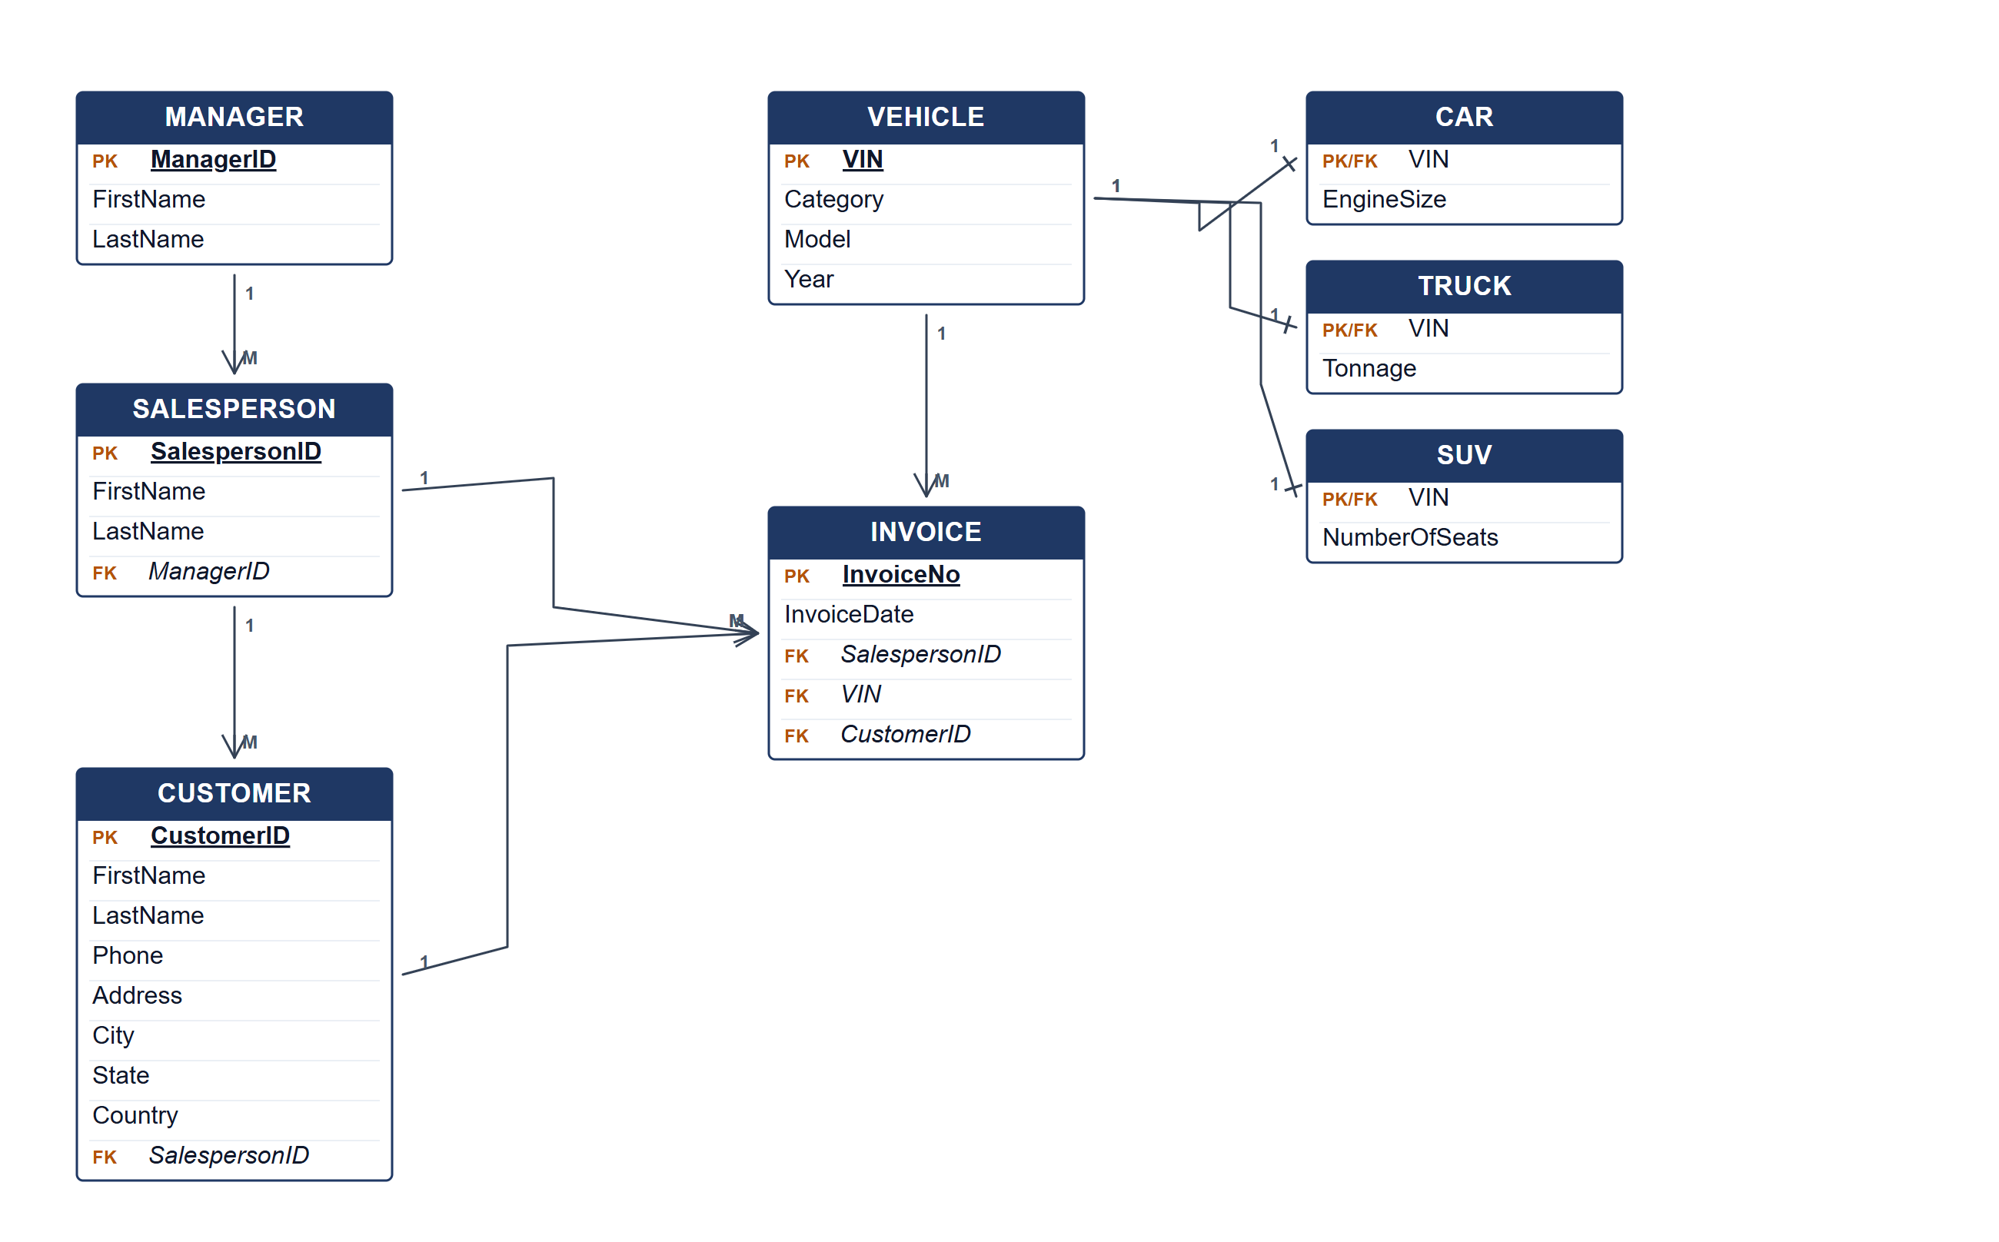
Car Dealership System ERD.
(b) Two reports from the ERD. [4 marks]
• Salesperson performance — invoices and sales value per salesperson, grouped by manager.
• Vehicle category report — number and value of cars, trucks and SUVs sold.
Marking guide
• a) 16 marks: manager/salesperson/customer (5); vehicle and three subtypes (5); invoice and relationships (4); keys (2).
• b) 2 marks for each report (4).
Provenance: model_unofficial · confidence medium · Model-authored from the approved question text, the supplied source assets and the ICT200/ICT450 knowledge base; no official ICT450 marking scheme was supplied.
Knowledge base basis: TOPIC 4 ERD_stu (2).pdf; TOPIC 3 RELATIONAL DATA MODELstu.pdf
Assumptions / notes
• A vehicle is one of Car, Truck or SUV, and an invoice records one vehicle sale.

